Semester Project 01

Autum 2019

# 1.0 Introduction

# 2.0 Body

## 2.1 Planning

On the first day of this project I started a mental laydown of how I must use my time after reading the assignment text. I found that in my plan there are four phases with each their own milestone. First phase was the planning phase with the and its milestone was delivery of the schedule document and gantt-chart.

Next came the research and development phase, which includes researching what pages I wanted and drawing up rough sketches, reviewing provided assets and creating supplements, create the layout markup for both handheld devices and computers, then implement all elements. And at the end concluding the phase with the completing development milestone.

Then came the testing phase, testing the website on real devices and chrome developer tools. For this phase the plan is to get fresh eyes on it letting a college look at it and explore the site. If everything checks out okay, the phase is concluded with the milestone “upload website to webhost”.

The phase of the project is writing the report, the plan was to take notes during the whole process, so it would be easier to write the report in the end. The fourth and final milestone is to submit the report with attachments and the link to the webpage.

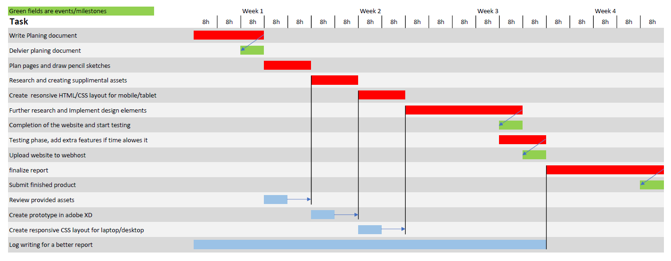

Fig. 1 Gantt-chart

A more comprehensive version of the plan is provided in the attachments;

Gantt-chart: 2019-11-02_semproj1_SondreLjovshin_FP01.pdf

Schedule document: 2019-11-02_semproj1_SondreLjovshin_FP02.pdf

## 2.2 Research

### 2.2.1 The pages

First thing I did when considering research was looking at the provided text document. By looking at the text I figured out what pages I wanted in my project and how I could use the text. Based on that I decided that I wanted to make an about us, exhibitions, pages for four exhibitions, events and a visit us page. I did not find too much text suited for a home page so that I had to do myself.

After deciding on the pages, I looked at the images to decide on what exhibitions to include on the webpage, I found some nice images for most exhibitions and decided on going with cosmology, evolution, biology and ecology.

### 2.2.2 The color scheme

When the pages were done I had to decide on my color scheme, I knew I wanted some diversity and something that was fitting for the exhibitions I chose to highlight on the webpage. Its was also important that the colors appealed to children. I wanted a yellow and orange mix, a blue, a red and pink mix, a green and grey. And of course, white and black.

These are the colors I decided on:

|  |  |  |  |  |
| --- | --- | --- | --- | --- |
|  | | | | |
| #FEFAA3 | #96D8F1 | #FBA5CD | #90F49B | #505050 |

### 2.2.3 The Sketch

This section is a short one, mainly because I did not find the process particularly helpful and I struggled to find inspiration for the sketch work. But I did draw something, during this process I found the general layout of the main viewports. As displayed below: 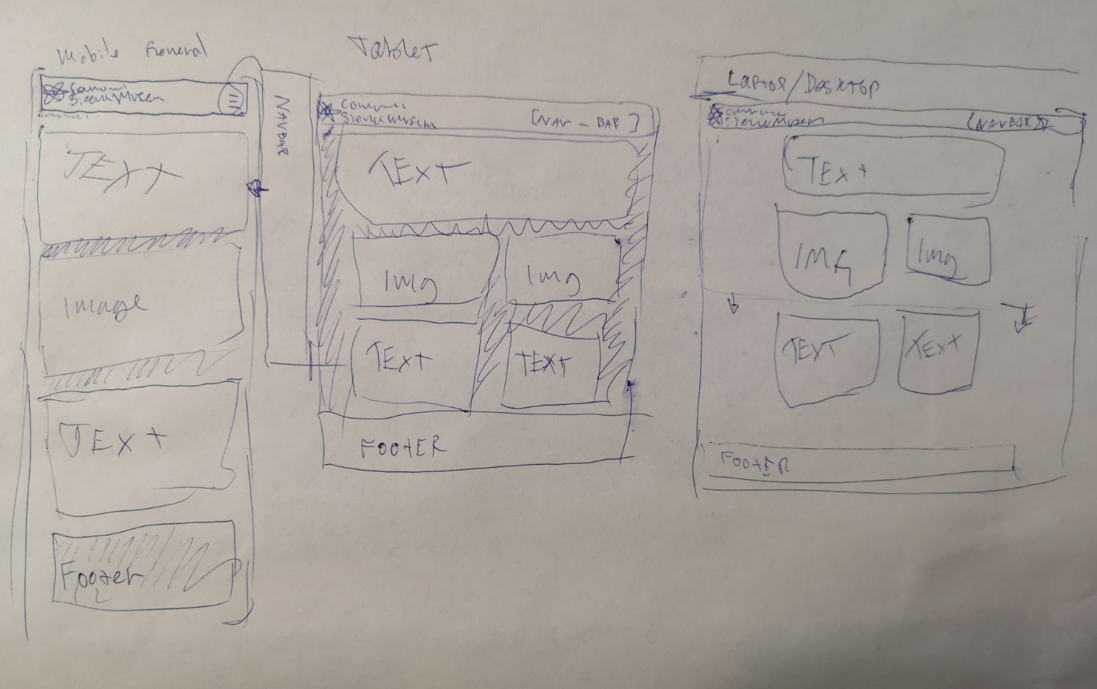

Fig. 2 sketch work for general layout

## 2.3 Design

### 2.3.1 The navigation menu

I knew from the moment I read the assignment that I wanted different menus on the mobile viewport and the bigger ones. I knew that if I wanted a sleek and user-friendly design for that number of pages on a mobile device I needed a navigation menu that was vertically aligned, and off screen when not prompted. I decided on a menu icon in the top right corner with a slide-in menu. Also, to make the whole website more accessible for mobile-users I decided to put in a menu item for the individual exhibitions as well as the item for the exhibitions page. On desktop there is no menu icon, but a horizontal navigation menu on the top right. On the desktop and tablet version I did not include the menu items for the individual exhibitions, because unlike the mobile version all “exhibition badges” are visible without scrolling on the exhibitions screen. And that concludes the decision making for the navigation menu.

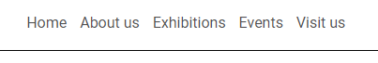

Fig. 3 Navigation menu for mobile devices

Fig. 4 Navigation menu for larger screens

### 2.3.2 The content containers

Fig. 5 Content containers

I wanted to keep the design simple and with repeating shapes and styles throughout the website. I decided to try out a container almost all content could go in to, I played around in adobe XD, and found out that a container that is about 94% of the width of the screen and as high as the content inside needs it to be with slightly rounded corners. Also tried the same for images with the same principles for width and height.

I tried a few different approaches on containers, with and without a background color, with and without padding on the inside. Then I thought the repeating shapes and styles throughout. I incorporated the color scheme in to the containers and alternated them randomly on every page.

I think it ended up looking quite clean, dynamic and interesting.

### 2.3.3 The Exhibition badges

Fig. 6 Exhibition badge

During my planning phase I decided that I wanted a page for the individual exhibitions, and a exhibitions page to create a page where the user can browse the exhibitions. I wanted to use something keep using the same style everywhere, so I decided to create a template badge to use as links.

### 2.3.4 The mockup

For this project did the whole mockup in Adobe XD, I think adobe XD is extremely efficient as a mockup tool when compared to photoshop or illustrator.

I started by throwing all the different elements I knew I wanted to use on to the artboard and created the header and footer. Then I created the content container template and found all the next elements I wanted to use. I pasted all the text in to the containers and fixed the colors.

On mobile the mockup was a quick, seeing that it was just all the different elements stacked on top of each other. The tablet version was a different story, I had to decide on how to move the elements and what goes where. I just tried a lot of different things without any actual plan or vision of how I wanted it to be, but I am happy with the result.

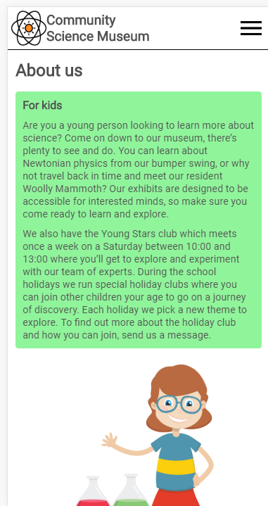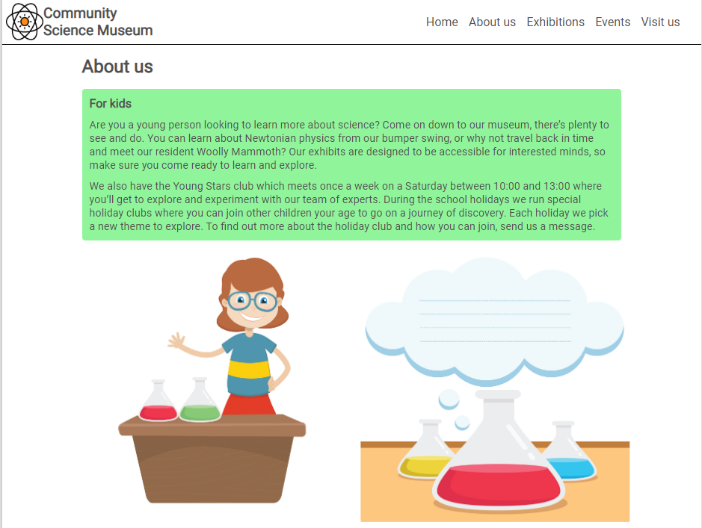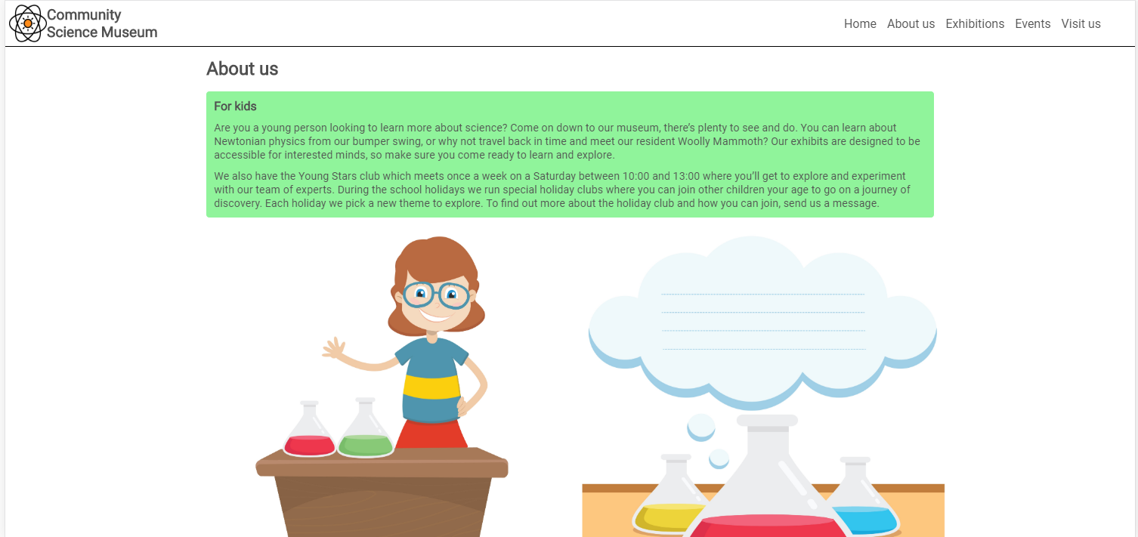

Fig. 7 Mackup example for mobile, tablet and laptop

## 2.4 Development

## 2.5 Testing

# 3.0 Conclusion